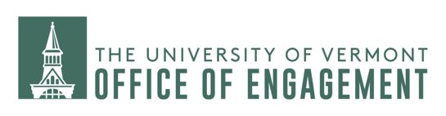

Annual Data Services Report to the RDCs: Addison County Economic Development Corporation

Provided by: UVM Office of Engagement
Provided to: Addison County Economic Development Corporation
Date: May 23rd, 2022

Data ascriptions:

The data platforms employed by the UVM require the proper ascription of data sources in the publication of data products (graphs, charts, figures). These ascriptions are embedded in every graph, chart and figure produced and should be included in any re-presentation of data in documents generated by UVM. UVM may request access to all documents produced by the receiver to ensure compliance with this contract.

Dissemination of publications and products derived from shared data:

The dissemination of publications and products derived from the data described under Data Overview is authorized only after the UVM Office of Engagement is notified through written notice of the intent to disseminate. The written notice of intent to disseminate must be received at least 7 days prior to the dissemination of the publication or product.

Receiver feedback and documentation expectations:

As a condition of receiving data services from UVM, you will be required to complete a short data use survey that will be forwarded within four weeks of delivery of each data product. You will have two weeks’ time to respond to this electronic survey to remain in compliance with this agreement. A data use survey will need to be completed for every data product produced by UVM.

Table of Contents:
 | Page
Demographics | 3
Labor Force | 8
Job Postings, Companies, and Skills | 10
Industries | 16
Occupations | 24

Demographic Profile

The below demographic profiles display comparative and trend data with respect to age, gender, education, race, and ethnicity, in addition to a series of social indicators that provide insight into the challenges and opportunities faced by Addison County, Vermont. The demographic data provided in this report is updated as of 2019, with data from the American Community Survey.

The data in Table 1 and Table 2 indicate decreasing populations of children under 18 years of age. They made up 21.3% of the population in 2010, and only 17.2% of the population in 2019. This is complemented by an aging population of individuals over the age of 55, with the age group of 55-64 year olds increasing from 13.6% to 15.6% between 2010 and 2019, and the group of 65-74 year olds increasing from 7.1% to 11.9% between 2010 and 2019.

Addison County has also experienced a shift in racial and ethnic distribution between 2010 and 2019. The percent of populations who identify as Black and Hispanic or Latino both increased by about 0.6% and 0.5%, respectively. The county’s population is still majority white, although the percentage of white individuals decreased by about 1.8% between 2010 and 2019.

Table 1. Demographic Profile of Addison County, VT by Percent
 | Percent
 | 2010 | 2011 | 2012 | 2013 | 2014 | 2015 | 2016 | 2017 | 2018 | 2019
Demographics
Population (ACS) | — | — | — | — | — | — | — | — | — | —
Male | 50.3% | 50.2% | 50.1% | 50.0% | 49.9% | 49.7% | 49.6% | 49.5% | 49.5% | 49.6%
Female | 49.7% | 49.8% | 49.9% | 50.0% | 50.1% | 50.3% | 50.4% | 50.5% | 50.5% | 50.4%
Median Age² | — | — | — | — | — | — | — | — | — | —
Under 18 Years | 21.3% | 20.9% | 20.3% | 19.7% | 19.2% | 18.7% | 18.2% | 17.9% | 17.5% | 17.2%
18 to 24 Years | 12.9% | 12.6% | 12.6% | 13.0% | 13.1% | 13.2% | 13.4% | 13.6% | 13.6% | 13.9%
25 to 34 Years | 9.4% | 9.5% | 9.6% | 9.5% | 9.7% | 10.0% | 9.9% | 9.9% | 10.0% | 9.9%
35 to 44 Years | 13.2% | 12.9% | 12.4% | 12.0% | 11.6% | 11.2% | 11.2% | 10.8% | 10.7% | 10.7%
45 to 54 Years | 16.5% | 16.4% | 16.3% | 16.0% | 15.6% | 15.2% | 14.8% | 14.4% | 14.0% | 13.6%
55 to 64 Years | 13.6% | 14.2% | 14.7% | 15.1% | 15.5% | 15.6% | 15.6% | 15.6% | 15.7% | 15.6%
65 to 74 Years | 7.1% | 7.4% | 7.8% | 8.3% | 8.8% | 9.4% | 10.2% | 10.8% | 11.4% | 11.9%
75 Years, and Over | 6.0% | 6.1% | 6.3% | 6.4% | 6.6% | 6.7% | 6.8% | 6.9% | 7.1% | 7.3%
Race: White | 95.7% | 95.8% | 95.7% | 95.5% | 95.3% | 94.9% | 94.7% | 94.5% | 94.2% | 93.9%
Race: Black or African American | 0.9% | 0.9% | 0.9% | 0.9% | 0.9% | 1.0% | 1.1% | 1.1% | 1.3% | 1.5%
Race: American Indian and Alaska Native | 0.3% | 0.3% | 0.3% | 0.3% | 0.3% | 0.4% | 0.3% | 0.3% | 0.3% | 0.4%
Race: Asian | 1.3% | 1.4% | 1.5% | 1.6% | 1.9% | 1.9% | 1.9% | 1.9% | 1.9% | 1.8%
Race: Native Hawaiian and Other Pacific Islander | 0.0% | 0.1% | 0.1% | 0.1% | 0.1% | 0.1% | 0.0% | 0.0% | 0.0% | 0.0%
Race: Some Other Race | 0.6% | 0.3% | 0.2% | 0.2% | 0.2% | 0.3% | 0.3% | 0.4% | 0.6% | 0.7%
Race: Two or More Races | 1.2% | 1.3% | 1.4% | 1.5% | 1.4% | 1.5% | 1.6% | 1.8% | 1.7% | 1.8%
Hispanic or Latino (of any race) | 1.8% | 1.8% | 1.8% | 1.9% | 2.0% | 2.1% | 2.1% | 2.2% | 2.3% | 2.3%

Source: Chmura’s JobsEQ, Demographic Profile: Addison County, VT, 2022.

Table 2. Demographic Profile of Addison County, VT by Value
 |  |  |  |  |  |  |  |  | Value
 | 2010 | 2011 | 2012 | 2013 | 2014 | 2015 | 2016 | 2017 |  | 2018 | 2019
Demographics
Population (ACS) | 36,841 | 36,835 | 36,814 | 36,811 | 36,883 | 36,943 | 36,926 | 36,825 |  | 36,939 | 36,882
Male | 18,520 | 18,484 | 18,438 | 18,405 | 18,395 | 18,355 | 18,312 | 18,214 |  | 18,272 | 18,302
Female | 18,321 | 18,351 | 18,376 | 18,406 | 18,488 | 18,588 | 18,614 | 18,611 |  | 18,667 | 18,580
Median Age² | 40.4 | 41.1 | 41.8 | 42.3 | 42.5 | 42.8 | 43.0 | 43.4 |  | 43.7 | 43.5
Under 18 Years | 7,865 | 7,689 | 7,475 | 7,245 | 7,064 | 6,912 | 6,723 | 6,602 |  | 6,474 | 6,341
18 to 24 Years | 4,763 | 4,646 | 4,648 | 4,773 | 4,841 | 4,872 | 4,964 | 5,016 |  | 5,040 | 5,121
25 to 34 Years | 3,461 | 3,507 | 3,529 | 3,503 | 3,581 | 3,684 | 3,639 | 3,639 |  | 3,695 | 3,663
35 to 44 Years | 4,873 | 4,754 | 4,547 | 4,404 | 4,276 | 4,148 | 4,120 | 3,995 |  | 3,942 | 3,933
45 to 54 Years | 6,074 | 6,048 | 6,003 | 5,882 | 5,739 | 5,631 | 5,450 | 5,285 |  | 5,168 | 5,007
55 to 64 Years | 5,000 | 5,247 | 5,419 | 5,573 | 5,702 | 5,764 | 5,762 | 5,763 |  | 5,788 | 5,742
65 to 74 Years | 2,606 | 2,711 | 2,885 | 3,068 | 3,262 | 3,473 | 3,748 | 3,986 |  | 4,223 | 4,398
75 Years, and Over | 2,199 | 2,233 | 2,308 | 2,363 | 2,418 | 2,459 | 2,520 | 2,539 |  | 2,609 | 2,677
Race: White | 35,253 | 35,283 | 35,217 | 35,166 | 35,138 | 35,053 | 34,962 | 34,807 |  | 34,783 | 34,625
Race: Black or African American | 338 | 315 | 320 | 317 | 322 | 355 | 411 | 395 |  | 482 | 541
Race: American Indian and Alaska Native | 97 | 108 | 114 | 93 | 107 | 130 | 112 | 100 |  | 124 | 130
Race: Asian | 465 | 509 | 554 | 605 | 688 | 696 | 707 | 711 |  | 714 | 663
Race: Native Hawaiian and Other Pacific Islander | 14 | 26 | 32 | 31 | 55 | 36 | 0 | 0 |  | 0 | 14
Race: Some Other Race | 219 | 104 | 68 | 62 | 68 | 110 | 125 | 153 |  | 210 | 240
Race: Two or More Races | 455 | 490 | 509 | 537 | 505 | 563 | 609 | 659 |  | 626 | 669
Hispanic or Latino (of any race) | 661 | 678 | 674 | 701 | 729 | 759 | 765 | 795 |  | 849 | 852

Source: Chmura’s JobsEQ, Demographic Profile: Addison County, VT, 2022.

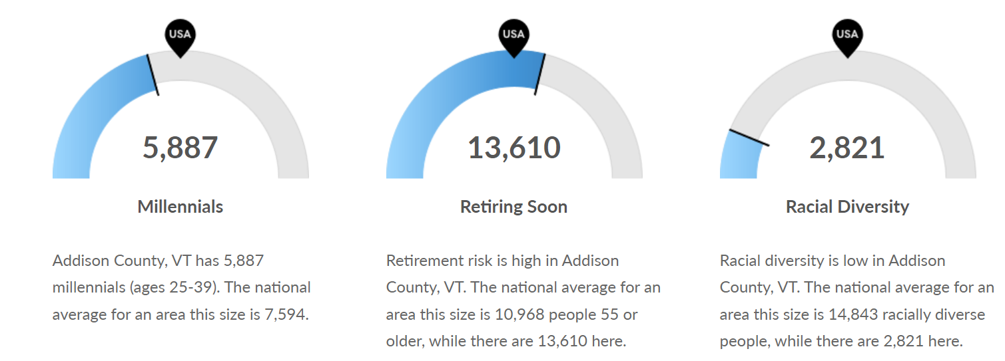
Source: EMSI, Economy Overview: Addison County, 2022.

Educational Attainment
Table 3 displays the trends in educational attainment in Addison County, VT between 2010 and 2019. This indicates a reduction in individuals with no high school diploma and just high school diplomas or GEDs, and an increase in individuals with associate’s degrees, bachelor’s degrees, and postgraduate degrees.
Table 3. Educational Attainment in Addison County, VT by Percent
Educational Attainment, Age 25-64
 | 2010 | 2011 | 2012 | 2013 | 2014 | 2015 | 2016 | 2017 | 2018 | 2019
No High School Diploma | 7.9% | 7.0% | 7.2% | 7.5% | 6.4% | 6.1% | 6.0% | 5.5% | 6.0% | 5.8%
High School Graduate | 34.9% | 33.5% | 32.8% | 32.5% | 31.9% | 32.2% | 31.6% | 31.4% | 30.9% | 29.3%
Some College, No Degree | 16.5% | 16.7% | 17.3% | 16.7% | 17.4% | 16.9% | 16.9% | 16.3% | 16.6% | 16.3%
Associate's Degree | 7.8% | 7.8% | 8.0% | 7.6% | 8.3% | 8.9% | 9.2% | 9.6% | 10.1% | 9.7%
Bachelor's Degree | 19.4% | 20.4% | 20.8% | 20.7% | 21.9% | 21.7% | 22.1% | 22.8% | 22.5% | 24.1%
Postgraduate Degree | 13.5% | 14.7% | 14.0% | 15.0% | 14.1% | 14.2% | 14.2% | 14.4% | 14.0% | 14.9%

Source: Chmura’s JobsEQ, Demographic Profile: Addison County, VT, 2022.

Housing
Housing units in Addison County, VT have steadily increased between 2010 and 2019, and is also reflected by an increasing median home value. Homeowner vacancy has increased, peaking in 2015 and 2016, while rental vacancies have decreased by 0.3%. Renter-occupied housing units have held steady around 24% between 2010 and 2019.
Table 4. Housing Stock and Value in Addison County, VT
Housing
 | 2010 | 2011 | 2012 | 2013 | 2014 | 2015 | 2016 | 2017 | 2018 | 2019
Total Housing Units | 16,619 | 16,703 | 16,760 | 16,767 | 16,843 | 16,891 | 16,971 | 17,213 | 17,336 | 17,431
Median House Value (of owner-occupied units)² | $219,000 | $228,600 | $235,500 | $234,500 | $235,200 | $237,300 | $236,400 | $237,000 | $241,900 | $249,700
Homeowner Vacancy | 1.1% | 1.3% | 2.7% | 2.9% | 3.1% | 3.4% | 3.4% | 2.3% | 2.1% | 1.9%
Rental Vacancy | 4.2% | 3.6% | 4.0% | 5.4% | 3.9% | 4.6% | 4.2% | 4.2% | 3.4% | 3.9%
Renter-Occupied Housing Units (% of Occupied Units) | 24.4% | 25.2% | 26.0% | 25.9% | 25.6% | 25.8% | 26.7% | 27.6% | 25.9% | 24.0%

Source: Chmura’s JobsEQ, Demographic Profile, Addison County, VT, 2022.

Labor Force

In this section, trends related to the labor force via labor force participation rate and job seeking and job posting are provided.

With respect to labor force participation rate, between the years of 2010 to 2019, Addison County, VT saw a decrease in labor force participation rate by 2.0%, and an increase in prime-age labor force participation rate by 1.5%. This likely indicates both the aging-out of many participants in the labor force and an increased participation of people between the ages of 25-54. These numbers were likely highly impacted by the COVID-19 pandemic. Data on total employment is provided for 2020 and 2021 in figure 1 and includes trends from 2010 to 2021Q1. This information displays the impact the COVID-19 pandemic had on employment and the recovery the region is experiencing.

Table 5. Labor Force Participation Rate in Addison County, VT by Percent
Economic
 | 2010 | 2011 | 2012 | 2013 | 2014 | 2015 | 2016 | 2017 | 2018 | 2019
Labor Force Participation Rate and Size (civilian population 16 years and over) | 69.1% | 68.0% | 68.7% | 67.7% | 67.4% | 67.1% | 66.7% | 66.8% | 66.9% | 67.1%
Prime-Age Labor Force Participation Rate and Size (civilian population 25-54) | 87.6% | 87.7% | 87.8% | 87.3% | 88.5% | 88.5% | 89.5% | 90.1% | 89.9% | 89.1%
Source: Chmura’s JobsEQ, Demographic Profile: Addison County, VT, 2022.

Table 6. Labor Force Participation Rate in Addison County, VT by Value
Economic
 | 2010 | 2011 | 2012 | 2013 | 2014 | 2015 | 2016 | 2017 | 2018 | 2019
Labor Force Participation Rate and Size (civilian population 16 years and over) | 20,886 | 20,643 | 20,895 | 20,681 | 20,748 | 20,728 | 20,760 | 20,779 | 20,930 | 20,996
Prime-Age Labor Force Participation Rate and Size (civilian population 25-54) | 12,617 | 12,538 | 12,349 | 12,035 | 12,018 | 11,913 | 11,815 | 11,630 | 11,503 | 11,220
Source: Chmura’s JobsEQ, Demographic Profile: Addison County, VT, 2022.

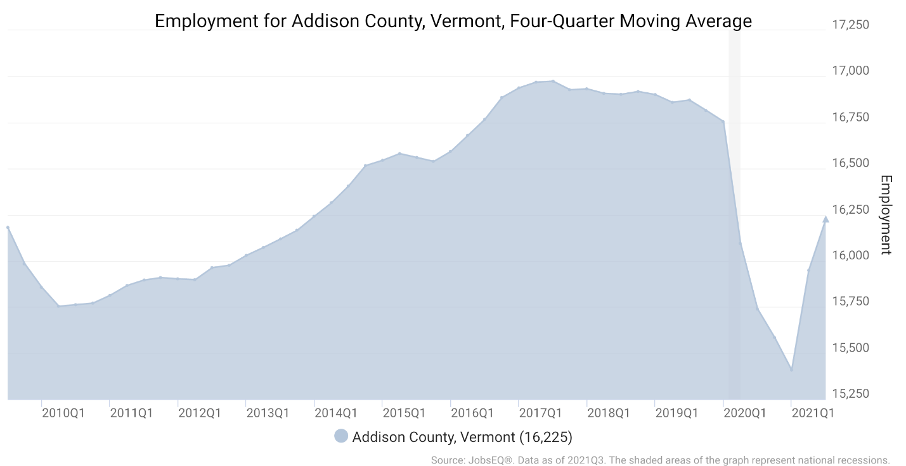
Figure 1. Employment for Addison County, VT. Retrieved from Chmura’s JobsEQ, Labor and Employment Trends, 2022.

These trends are complemented by data on median household and per capita income in Addison County. Over the last ten years, the region has experienced an increase in both household and per capita income.

Table 7. Median Household Income and Per Capita Income in Addison County, VT
Economic
 | 2010 | 2011 | 2012 | 2013 | 2014 | 2015 | 2016 | 2017 | 2018 | 2019
Median Household Income² | $55,800 | $57,203 | $57,785 | $57,565 | $59,274 | $59,688 | $61,020 | $61,875 | $65,093 | $68,825
Per Capita Income | $26,599 | $27,683 | $28,550 | $28,722 | $29,295 | $29,561 | $30,154 | $31,051 | $33,120 | $34,741
Source: Chmura’s JobsEQ, Demographic Profile: Addison County, VT, 2022.

Job Postings and Skill Gaps

The below charts outline the top job postings for Addison County, VT by occupation code. Registered nurses represented the largest job posting group, followed by workers in the retail and wholesale, transportation, and social and human services industries. Two sources, Chmura’s JobsEQ and EMSI, are utilized to display different methodologies.

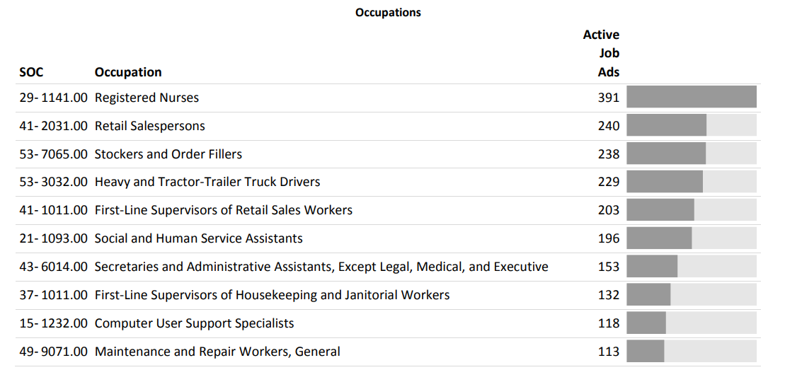
Figure 2. Top Job Postings between March 2021-March 2022 in Addison County, VT, 2022. Retrieved from Chmura’s JobsEQ Real Time Intelligence Job Posting Analytics, 2022.

Job posting analytics provide real-time information about job seekers and job postings. The below figures display the top posted occupations, job titles, and in-demand skills for the last five years in Addison County, VT.
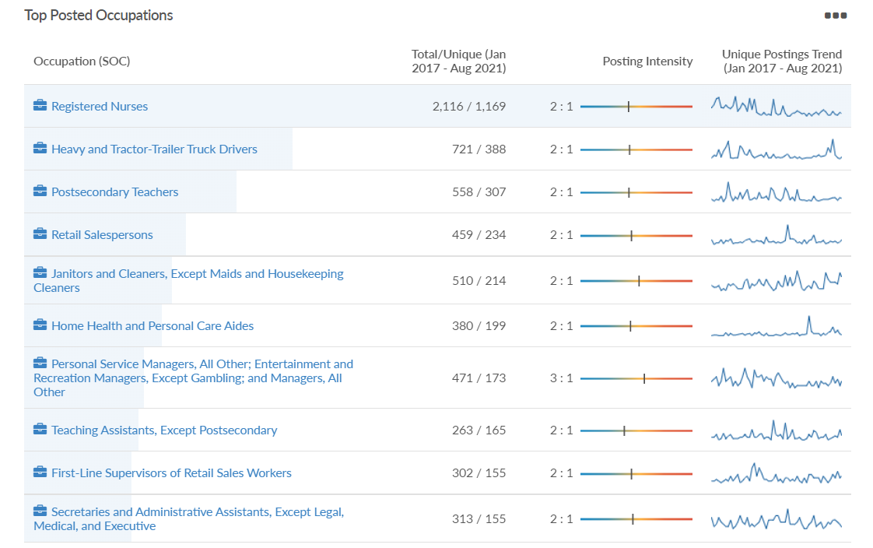
Figure 3. Job Posting Analytics for Top Advertised Occupations in Addison County, VT, 2017-2021. Retrieved from EMSI, 2022.

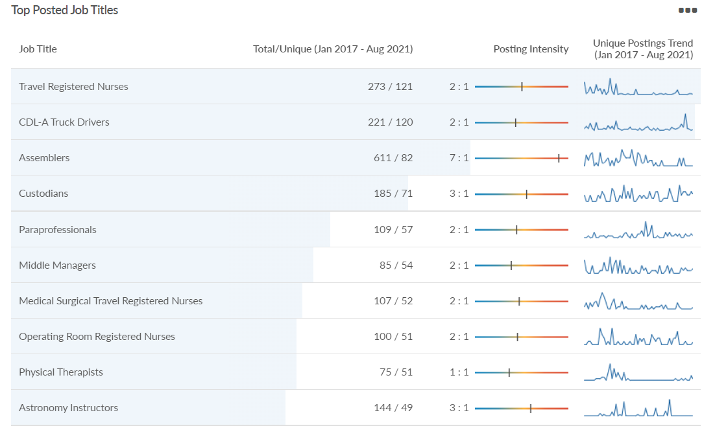
Figure 4. Job Posting Analytics for Top Advertised Job Titles in Addison County, VT, 2017-2021. Retrieved from EMSI, 2022.

In demand skills display comparative information regarding the frequency in job postings vs. the frequency with which that in-demand skill appears in job seeker profiles. This emphasized the mismatch between demand and supply in certain occupations. In this case, skills related to nursing are in high demand and low supply.
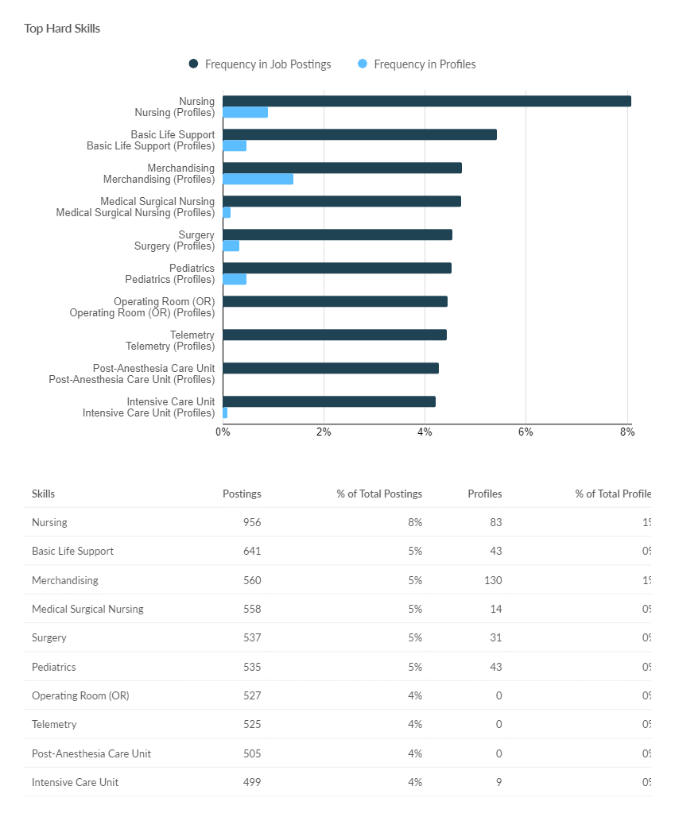
Figure 5. Job Posting Analytics for Top in Demand Skills in Addison County, VT, 2017-2021. Retrieved from EMSI, 2022.

In figure 6, the top companies posting for jobs in Addison County is included. Middlebury College and United Technologies Corporation lead the pack with job postings between 2017 and 2021. Many of these posts represent businesses that have merged over time. For instance, United Technologies Corporation and UTC Aerospace are now Collins Aerospace, which is part of Raytheon Technologies.
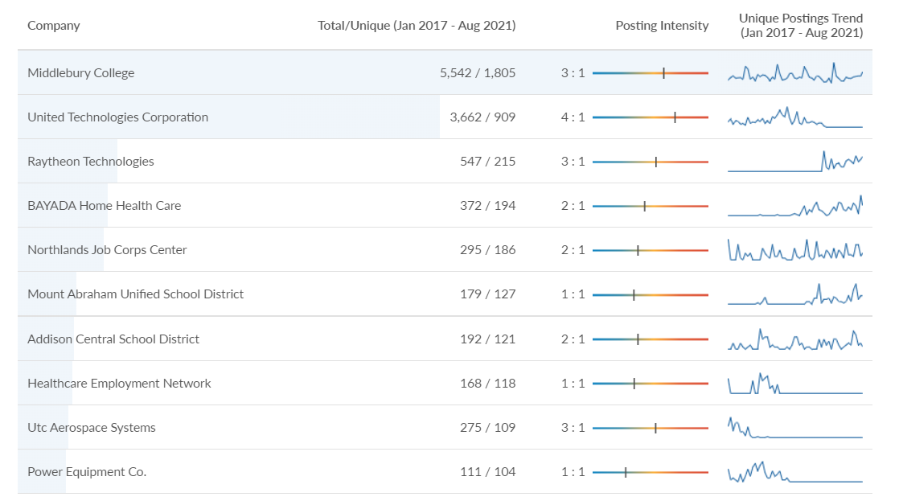
Figure 6. Top Hiring Companies in Addison County, VT, 2017-2021. Retrieved from EMSI, 2022.

Additionally, there is a repository of skills in Addison County, VT. Some are in high demand, some are in low demand. The below chart indicates skills and certifications where there is a supply deficit (red bars) and supply surplus (blue bars). Skills and certifications related to healthcare, retail, and computing are all in low supply in Addison County, VT.

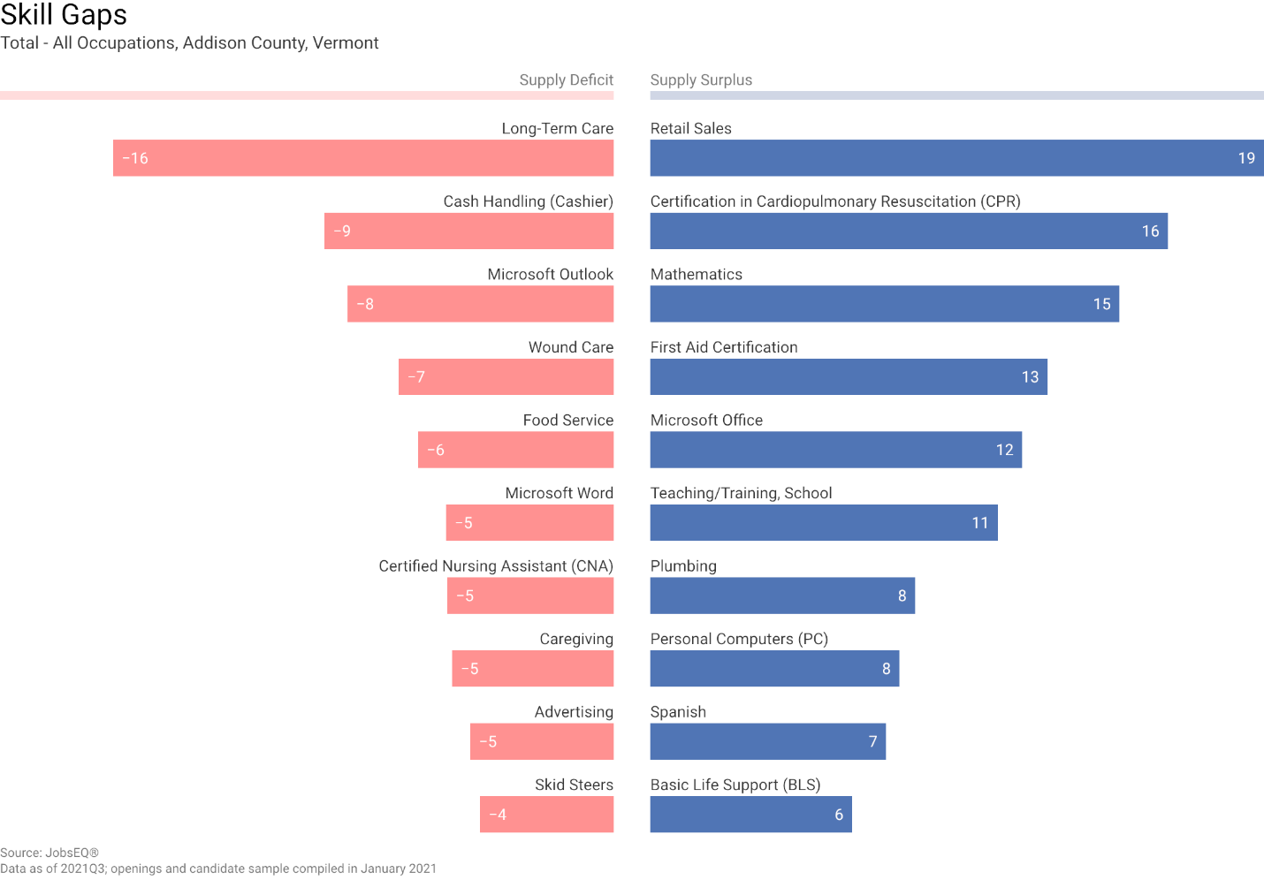
Figure 7. Skill Gaps for Addison County, VT, 2022. Retrieved from Chmura’s JobsEQ, Skill Gaps: Addison County, VT, 2022.

Industries

This section includes information on the industries with the highest location quotients in Addison County, in addition to the largest, highest paying, and lowest paying industries in Addison County.

A location quotient (LQ) is a measurement of concentration in comparison to the nation. An LQ of 1.00 indicates a region has the same concentration of an industry (or occupation) by number of jobs relative to the nation. An LQ of 2.00 would mean the region has twice the expected employment compared to the nation and an LQ of 0.50 would mean the region has half the expected employment in comparison to the nation.

In Addison County, the industries with the top location quotients are:

NAICS | Industry | Employment | Avg Annual Wages | LQ
334519 | Other Measuring and Controlling Device Manufacturing | 787 | $90,360 | 217.66
315990 | Apparel Accessories and Other Apparel Manufacturing | 72 | $39,992 | 54.76
112120 | Dairy Cattle and Milk Production | 470 | $41,570 | 42.12
213115 | Support Activities for Nonmetallic Minerals (except Fuels) Mining | 11 | $39,147 | 32.76
112910 | Apiculture | 12 | $41,329 | 31.27
312140 | Distilleries | 65 | $48,057 | 31.04
311119 | Other Animal Food Manufacturing | 104 | $85,006 | 27.36
212319 | Other Crushed and Broken Stone Mining and Quarrying | 18 | $37,254 | 22.72
339930 | Doll, Toy, and Game Manufacturing | 29 | $83,972 | 21.95
339910 | Jewelry and Silverware Manufacturing | 61 | $50,058 | 20.58
Figure 8. Top Location Quotients by Industry in Addison County, VT, 2021. Chmura’s JobsEQ, Industry Spotlight: Addison County, 2022.

Industry Clusters:
A cluster is a geographic concentration of interrelated industries or occupations. The industry cluster in Addison County, VT with the highest relative concentration is Electric/Electronics Manufacturing, with a location quotient of 4.89.

Electric/Electronics Manufacturing employs 839 workers in Addison County, with an average wage of $90,481. Employment in Electric/Electronics Manufacturing is projected to contract in the region at a rate of 0.8% per year over the next ten years.

Figure 9. Location Quotient Industry Clusters for Addison County, VT in 2021. Chmura’s JobsEQ, Industry Overview: Addison County, VT, 2022.

Below are tables that display the top ten industries (by 6-digit NAICS code) which have the most jobs, highest pay, and lowest pay in Addison County, VT. The data displays an 11-year time horizon, the change in jobs between 2010 and 2021, and the earnings/worker for 2021.

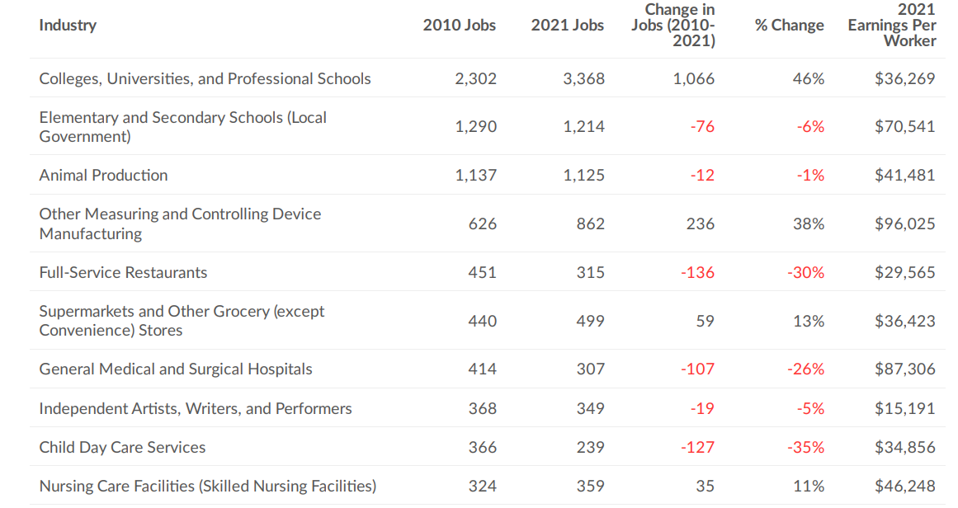
Figure 10. Largest Industries in Addison County, 2010-2021. Retrieved from EMSI, 2022.

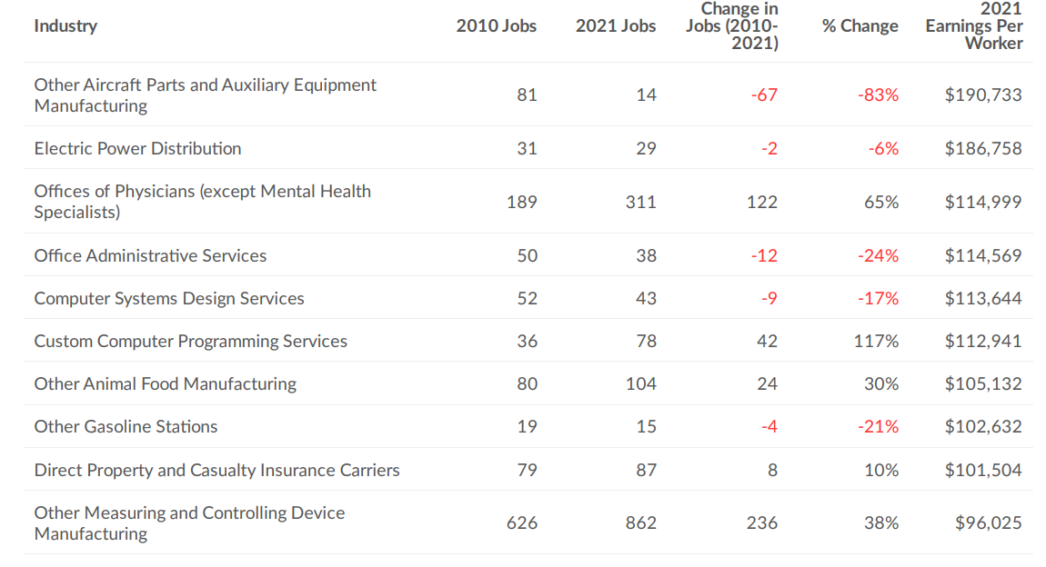
Figure 11. Highest Paying Industries in Addison County, 2010-2021. Retrieved from EMSI, 2022.

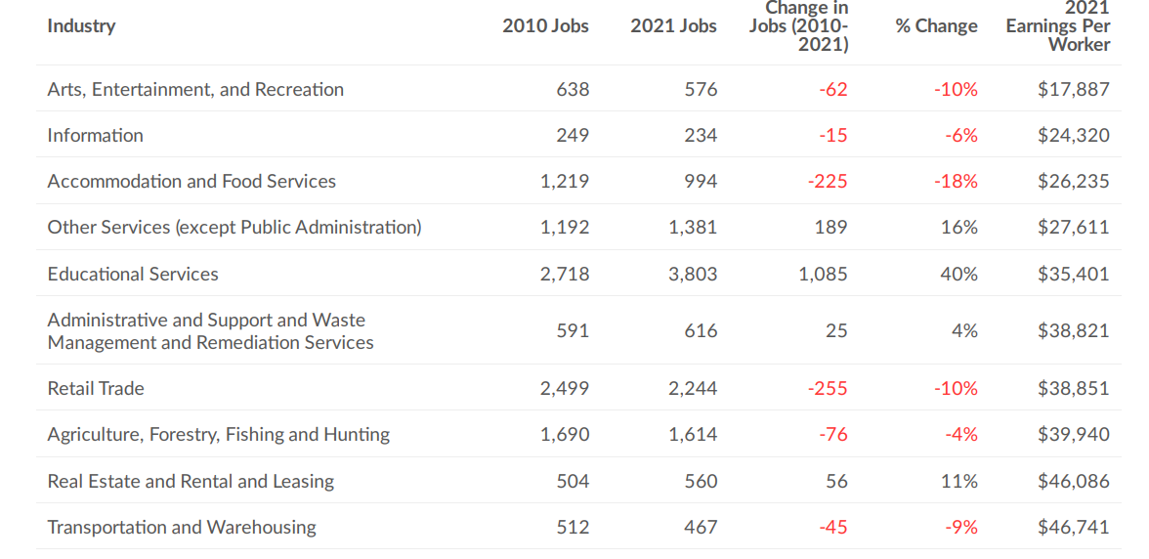
Figure 12. Lowest Paying Industries in Addison County, 2010-2021. Retrieved from EMSI, 2022.

And finally, a selection of industries are quantified by their change in establishments over the last ten years. Industries of interest include retail, agriculture, food service and accommodations, and high tech.

In 2020, there were 150 Retail Trade establishments in Addison County, Vermont (per covered employment establishment counts), a decrease from 188 establishments ten years earlier in 2010.

Figure 12. Retail Trade Establishments in Addison County, VT, 2010-2020. Retrieved from Chmura’s JobsEQ, 2022.

In 2020, there were 80 Agricultural (Chmura Cluster) establishments in Addison County, Vermont (per covered employment establishment counts), an increase from 78 establishments ten years earlier in 2010.

Figure 13. Agricultural Establishments in Addison County, VT, 2010-2020. Retrieved from Chmura’s JobsEQ, 2022.

In 2020, there were 76 Accommodation and Food Services establishments in Addison County, Vermont (per covered employment establishment counts), unchanged from 76 establishments ten years earlier in 2010.
Figure 14. Accommodation and Food Service Establishments in Addison County, VT, 2010-2020. Retrieved from Chmura’s JobsEQ, 2022.

In 2020, there were 193 Total High-Tech establishments in Addison County, Vermont (per covered employment establishment counts), an increase from 121 establishments ten years earlier in 2010.
Figure 15. High Tech Establishments in Addison County, VT, 2010-2020. Retrieved from Chmura’s JobsEQ, 2022.

Occupations
The below figures indicate the occupations in Addison County, VT with the most workers, highest pay, and lowest pay. The timespan includes 2010-2021.

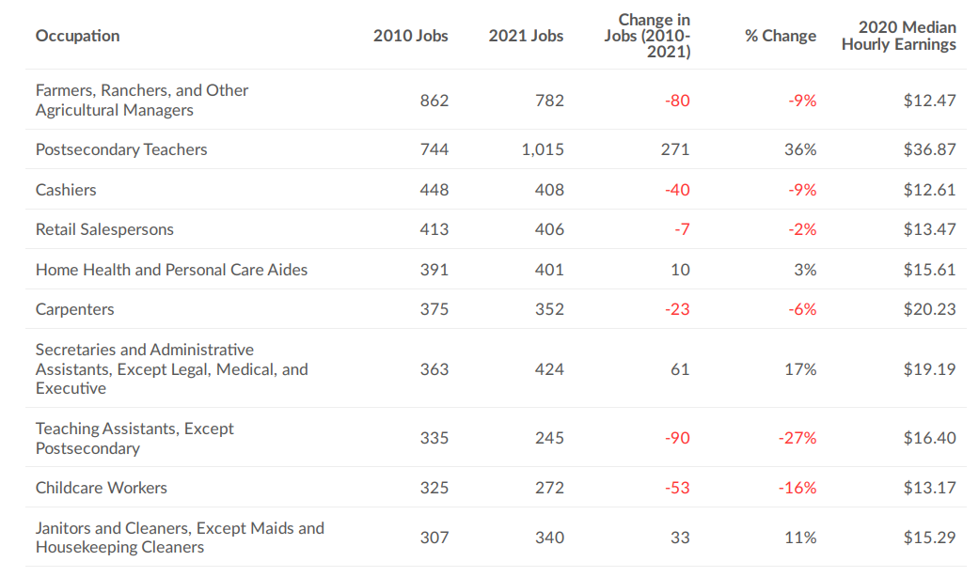
Figure 16. Largest Occupations in Addison County, 2010-2021. Retrieved from EMSI, 2022.

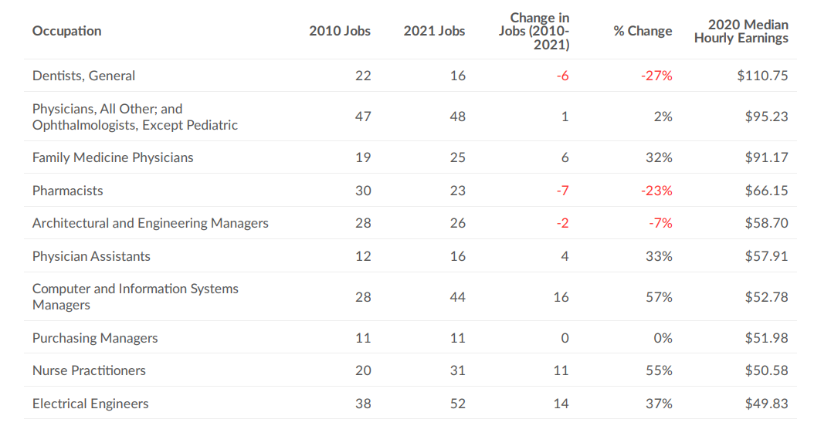

Figure 17. Highest Paying Occupations in Addison County, 2010-2021. Retrieved from EMSI, 2022.

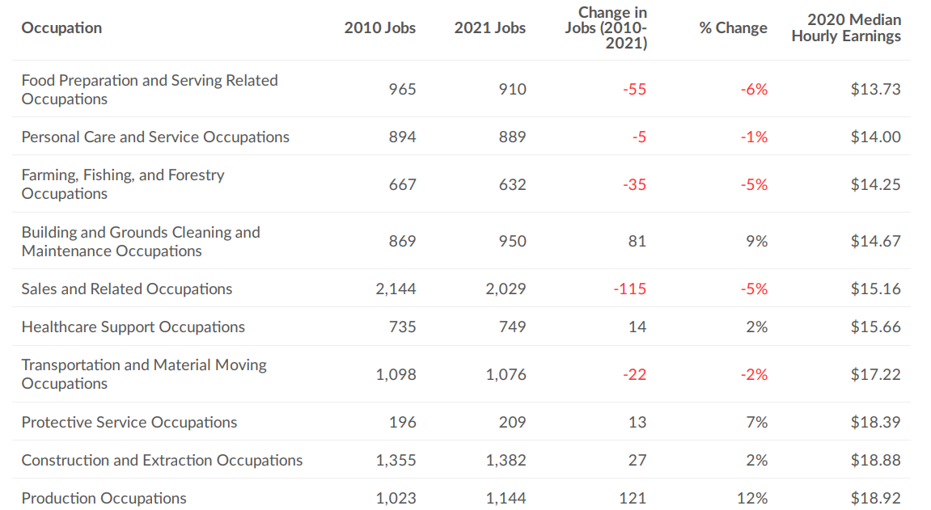
Figure 18. Lowest Paying Occupations in Addison County, 2010-2021. Retrieved from EMSI, 2022.

